Date: 08/06/2026
BATTERY STATE-OF-CHARGE ESTIMATION USING EXTENDED KALMAN FILTERWITH TEMPERATURE-DEPENDENT RC MODEL
Project Report
Submitted by:
Manoj Ravi
Tools Used: MATLAB / Simulink

1. INTRODUCTION

Battery State-of-Charge (SOC) estimation is one of the most important functions in Battery Management Systems (BMS) used in electric vehicles, renewable energy systems, and portable electronics. Accurate SOC estimation helps improve battery safety, reliability, efficiency, and lifetime.

Traditional SOC estimation methods such as Coulomb Counting are simple to implement but suffer from cumulative drift errors due to current sensor noise and bias. These errors become significant during long-duration operation and varying load conditions.

To overcome these limitations, this project implements an Extended Kalman Filter (EKF) based SOC estimation approach using a second-order RC equivalent circuit battery model in MATLAB/Simulink. The EKF combines model prediction with measured terminal voltage to improve estimation accuracy under noisy conditions.

The project also includes current sensor bias estimation and temperature-dependent parameter variation analysis to study the effect of changing battery temperature on system behaviour and SOC estimation performance.

Simulation results demonstrate the effectiveness of the EKF in tracking battery SOC under dynamic current profiles while reducing estimation error compared to conventional Coulomb Counting methods.

2. OBJECTIVES

The main objectives of this project are:

• To develop a second-order RC equivalent circuit model of a lithium-ion battery.
• To implement an Extended Kalman Filter (EKF) for battery State-of-Charge estimation.
• To compare EKF-based SOC estimation with traditional Coulomb Counting methods.
• To estimate and compensate current sensor bias during battery operation.
• To analyse the effect of temperature-dependent parameter variation on battery dynamics and SOC estimation.
• To simulate the complete Battery Management System model using MATLAB/Simulink.

3. BATTERY MODELING

A second-order RC equivalent circuit model was used to represent the dynamic behaviour of the lithium-ion battery. The model consists of an open-circuit voltage source, internal resistance, and two RC polarization networks that capture transient voltage response characteristics.

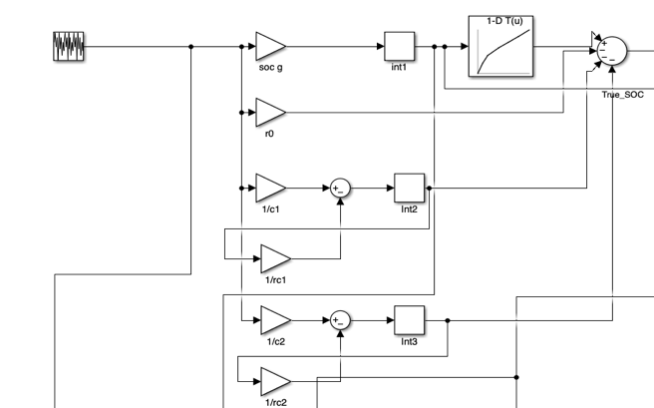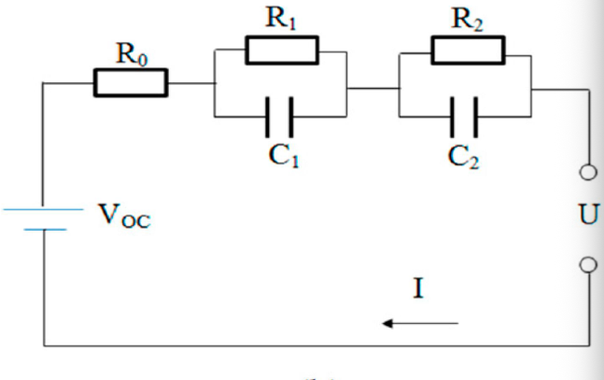
Figure 1: Second-order RC equivalent circuit battery model implemented in Simulink.

The RC networks help model short-term and long-term voltage dynamics during charging and discharging conditions. The battery terminal voltage is influenced by internal resistance losses and polarization effects represented by the RC branches.

The state variables used in the model are:

• State-of-Charge (SOC)
• RC branch voltage $V_{1}$
• RC branch voltage $V_{2}$
• Current sensor $bais_{I}$

The SOC update equation is given by:
$$SOC_{k+1}=SOC_{k}-\frac{Δt}{Q_{b}}(I_{k}-bias_{k})$$
where Qb represents battery capacity and I represents battery current.
The RC branch dynamics are modelled using discrete-time exponential equations which capture transient battery voltage behaviour during varying load conditions.
The Extended Kalman Filter (EKF) was implemented in MATLAB/Simulink to estimate the battery State-of-Charge under noisy and dynamic operating conditions. Unlike conventional Coulomb Counting methods, the EKF continuously corrects the estimated SOC using measured terminal voltage feedback and system model predictions.

4. EXTENDED KALMAN FILTER IMPLEMENTATION
The implemented EKF uses a nonlinear second-order RC battery model and estimates the following state variables:
• State-of-Charge (SOC)
• RC branch voltage $V_{1}$
• RC branch voltage $V_{2}$
• Current sensor $bais_{I}$
The state vector is represented as:
$$x=\left[\begin{matrix}SOC \\ V_{1} \\ \begin{matrix}V_{2} \\ bais_{I}\end{matrix}\end{matrix}\right]$$

The EKF operates in two main stages: prediction and correction. During the prediction stage, the battery model is used to estimate the next system state using the measured current input. During the correction stage, the predicted terminal voltage is compared with the measured terminal voltage to reduce estimation error.

The Kalman Gain is computed dynamically to balance model uncertainty and measurement uncertainty during estimation.
$$K_{k }=P_{k}{H_{k}}^{T}{{\left(H_{k}P_{k}{H_{k}}^{T}+R_{K}\right)}^{-}}^{1}$$

The EKF also estimates current sensor bias as an additional state variable. This improves robustness against sensor offset errors that typically cause drift in conventional SOC estimation methods.

A MATLAB Function block was used to implement the EKF prediction and update equations within the Simulink environment. The covariance matrices were tuned experimentally to achieve stable and accurate estimation performance under dynamic load conditions.

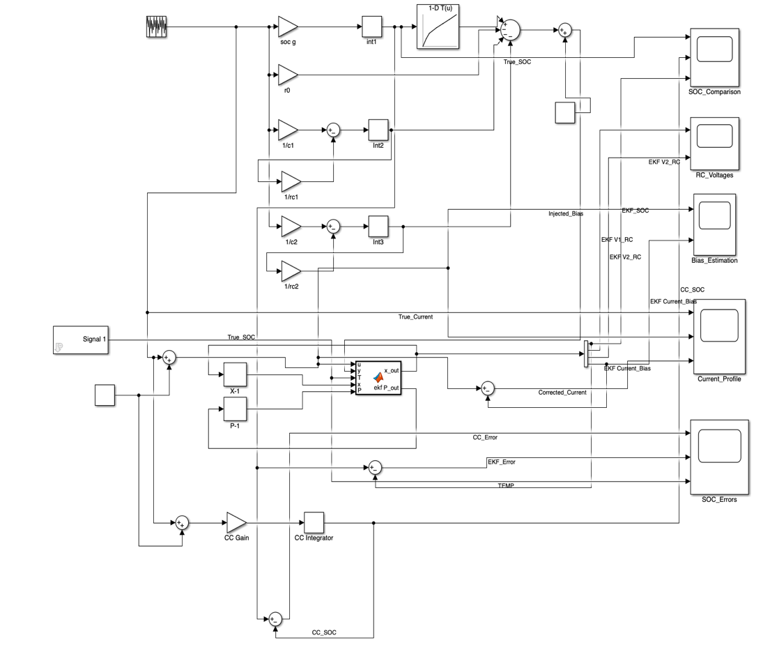
Figure 2: Complete Simulink implementation of the EKF-based battery SOC estimation system.

The complete system includes the battery model, current profile generation, Coulomb Counting comparison, temperature-dependent parameter variation, bias injection, and EKF-based state estimation blocks integrated within a single Simulink framework.

5. TEMPERATURE-DEPENDENT PARAMETER ANALYSIS

Battery parameters vary significantly with temperature, which directly affects terminal voltage behaviour, internal resistance, and SOC estimation accuracy. To study these effects, temperature-dependent resistance variation was incorporated into the second-order RC battery model.

In this project, the resistive parameters R0, R1, and R2 were modified as functions of temperature using experimentally tuned coefficients. Lower temperatures increase the effective internal resistance of the battery, resulting in larger voltage drops and stronger polarization effects during charging and discharging conditions.

A temperature profile was applied in Simulink using a step-based thermal variation signal. The temperature was varied from 25°C to 0°C and later restored to 25°C in order to observe transient estimator behaviour and system recovery characteristics.

The temperature-dependent resistance equations are given by:
- $R_{0}=R_{0,ref}(1+α_{0}(25-T))$
- $R_{1}=R_{1,ref}(1+α_{1}(25-T))$
- $R_{2}=R_{2,ref}(1+α_{2}(25-T))$
The simulation results showed noticeable changes in RC voltage dynamics and EKF transient response during temperature transitions. The estimator remained stable under varying thermal conditions, demonstrating the robustness of the implemented EKF-based SOC estimation framework.

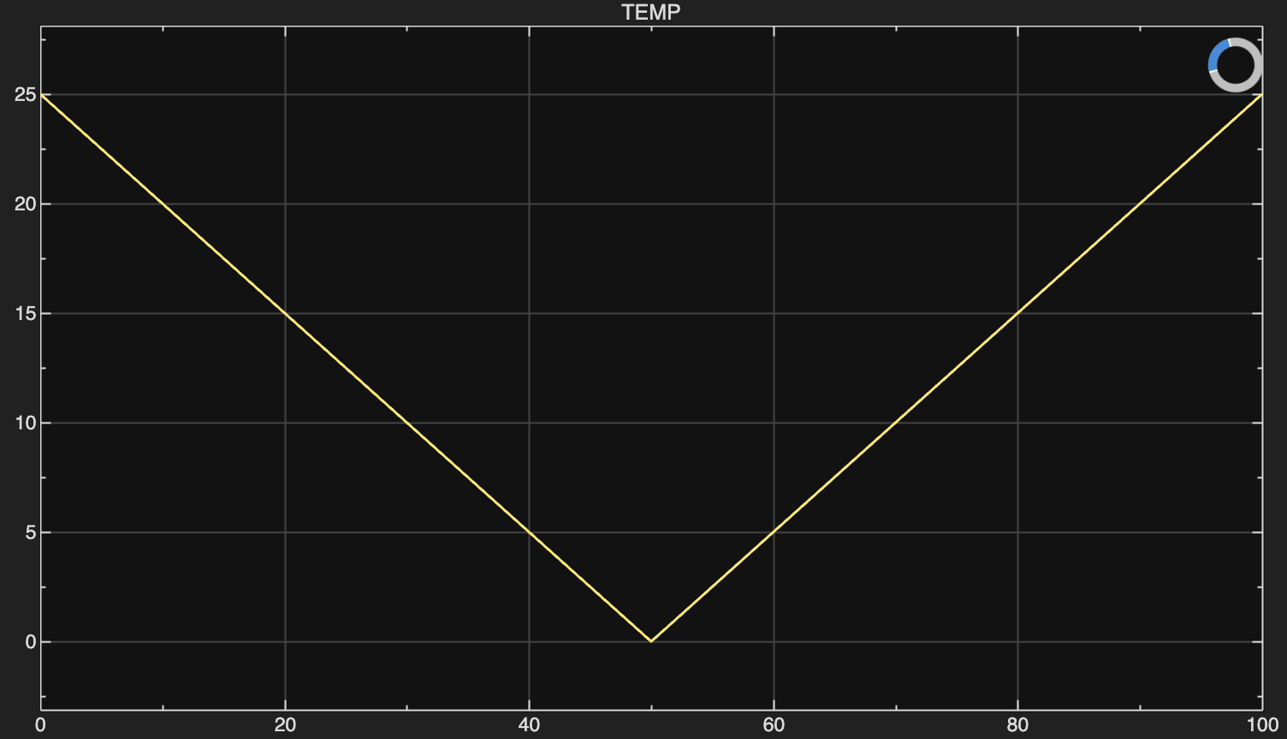
Figure 3: Applied temperature profile used for thermal sensitivity analysis.

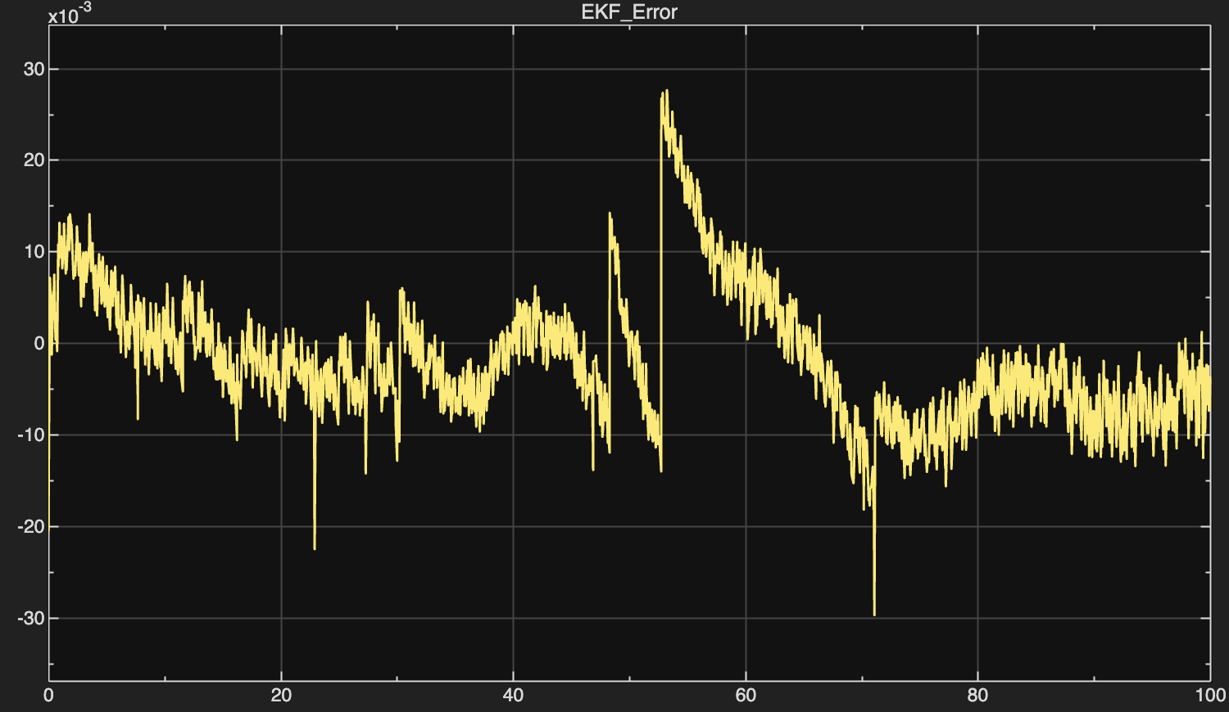
Figure 4: Effect of temperature variation on RC voltage dynamics and EKF response.

6. SIMULATION RESULTS AND DISCUSSION

The developed battery model and Extended Kalman Filter were simulated in MATLAB/Simulink under dynamic current loading conditions. Various operating scenarios including current sensor bias injection and temperature-dependent parameter variation were analyzed to evaluate estimation performance and system behaviour.

The following results demonstrate the effectiveness of the implemented EKF-based SOC estimation framework.

RESULT 1 — SOC Comparison

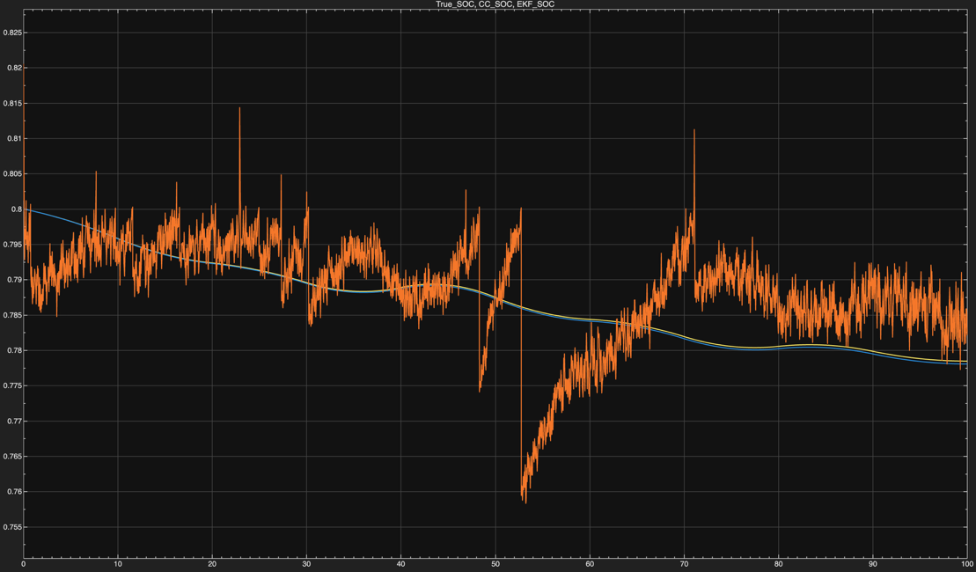
Figure 5: Comparison of true SOC, EKF-estimated SOC, and Coulomb Counting SOC.

Figure 5 shows the comparison between true SOC, EKF-estimated SOC, and Coulomb Counting SOC under dynamic operating conditions. The EKF was able to closely track the true SOC despite current sensor bias, measurement noise, and temperature variation. In contrast, the Coulomb Counting method showed larger drift and transient deviation during sudden operating condition changes. The results demonstrate the improved robustness and correction capability of the EKF-based estimation approach.

RESULT 2 — RC Voltage Dynamics
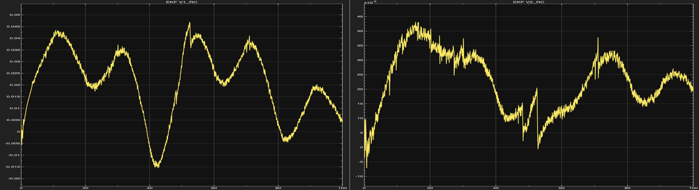
Figure 6: RC polarization voltage dynamics under varying current and temperature conditions.
Figure 6 shows the estimated RC polarization voltages obtained from the second-order RC battery model used within the EKF framework. The V1_RC state captures the faster transient response, while V2_RC represents slower diffusion-related battery dynamics during varying current conditions. Changes in waveform shape and transient peaks were observed during temperature variation, indicating the effect of temperature-dependent parameter adaptation on the internal battery behaviour. The results confirm that the EKF successfully tracked both short-term and long-term polarization effects in the battery model.

RESULT 3 — Bias Estimation Performance
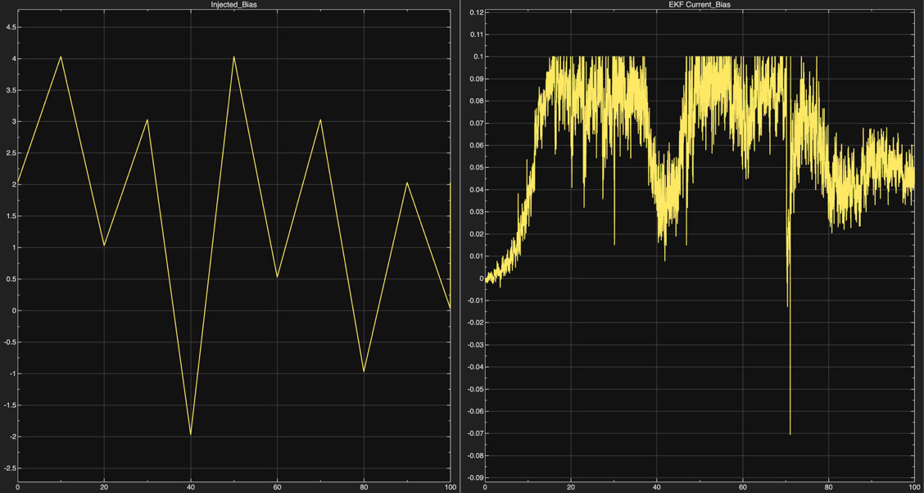
Figure 7: Injected current sensor bias and EKF-estimated bias comparison.

Figure 7 shows the comparison between the injected current sensor bias and the EKF-estimated bias signal during dynamic operating conditions. The EKF successfully captured the overall variation trend of the injected bias despite the presence of noise and sudden transient changes. Estimation fluctuations and short-duration spikes were observed during rapid bias transitions; however, the filter maintained stable tracking behaviour throughout the simulation. The results demonstrate the effectiveness of the EKF in compensating for current sensor errors and improving estimation reliability.

RESULT 4 — Current Profile and Bias Compensation

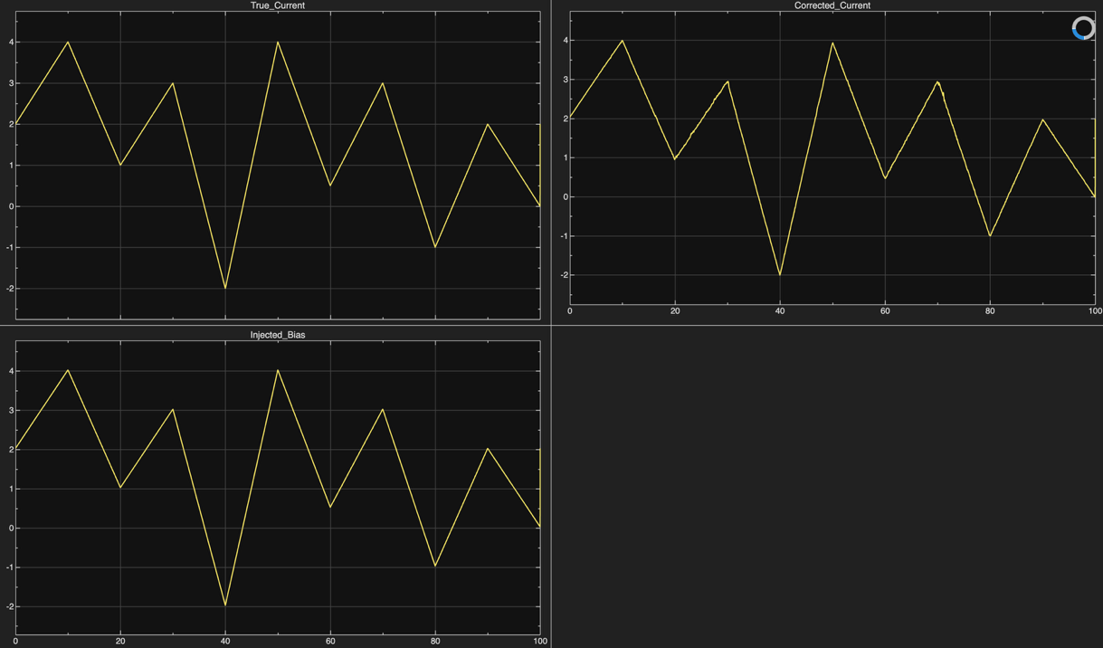
Figure 8: True current, injected bias, and EKF-corrected current response.

Figure 8 illustrates the applied battery current profile together with the EKF-corrected current signal under dynamic operating conditions. The corrected current closely followed the true current profile, indicating successful compensation of sensor bias and measurement disturbances by the EKF algorithm. The system maintained stable current reconstruction even during rapid current transitions and polarity changes. These results demonstrate the effectiveness of the EKF-based bias correction mechanism in improving current measurement reliability and overall SOC estimation performance.

RESULT 5 — SOC Error Analysis and Temperature Variation

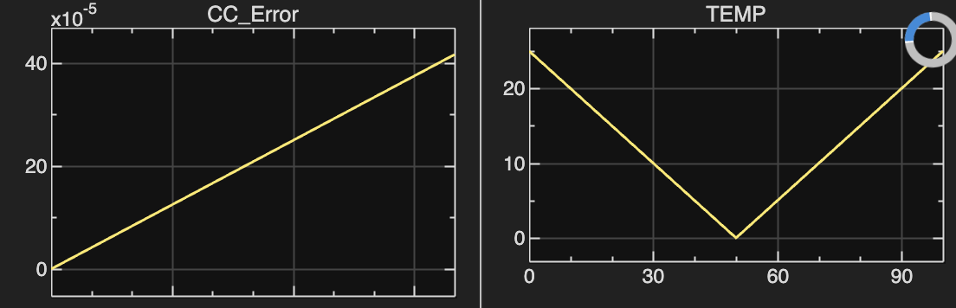
Figure 9: SOC estimation error comparison and temperature variation during simulation.

Figure 9 presents the SOC estimation error behaviour for both the Coulomb Counting method and the EKF-based estimation approach under varying temperature conditions. The Coulomb Counting method showed gradual drift accumulation over time due to current integration error and sensor bias effects. In comparison, the EKF maintained lower estimation error and demonstrated improved robustness against disturbances and temperature-dependent parameter variation. The temperature profile introduced dynamic operating condition changes, allowing evaluation of estimator adaptability under realistic battery operating scenarios.

7. CONCLUSION

In this project, an Extended Kalman Filter (EKF)-based battery State of Charge (SOC) estimation system was successfully developed and implemented in MATLAB/Simulink using a second-order RC battery model. The developed system incorporated current sensor bias estimation and temperature-dependent parameter variation to improve estimation accuracy and robustness under dynamic operating conditions.

Simulation results demonstrated that the EKF provided more stable and accurate SOC estimation compared to the conventional Coulomb Counting method, particularly during transient current variations, injected sensor bias, and temperature changes. The EKF was also capable of estimating internal RC polarization voltages and compensating for measurement disturbances in real time.

The proposed framework provides an effective foundation for advanced Battery Management System (BMS) applications in electric vehicles and energy storage systems. The developed model can be further extended toward real-time embedded implementation, adaptive parameter estimation, and hardware-based validation for practical applications.

The project demonstrates practical application of estimation algorithms, battery modeling, signal processing, and MATLAB/Simulink-based system-level design for modern Battery Management System (BMS) applications.

